Business Question and Visualization Report
Team ID | MCA
Project Name | Smartphone Usage, Digital Addiction & Well-Being Analytics
Maximum Marks | 5 Marks

Visualization development refers to the process of creating graphical representations of data to facilitate understanding, analysis, and decision-making. The goal is to transform complex datasets into visual formats that are easy to interpret, enabling users to gain insights and make informed decisions. Visualization development involves selecting appropriate visual elements, designing layouts, and using interactive features to enhance the user experience. This process is commonly associated with data visualization tools and platforms, and it plays a crucial role in business intelligence, analytics, and reporting.
Business Questions and Visualisation
The process involves defining specific business questions to guide the creation of meaningful and actionable visualizations in Power BI. Well-framed questions help in identifying key metrics, selecting relevant data, and building visualisations that provide insights.
Question 1
How does daily smartphone screen time differ across genders?
- Visualization: Column chart showing Average Daily Screen Time by Gender (Male, Other, Female).
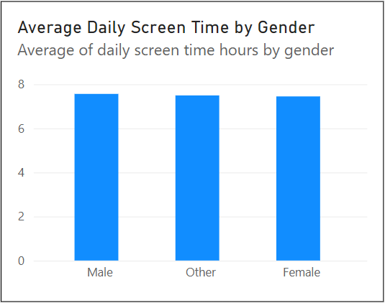

Question 2
How are users distributed across different addiction severity levels?
- Visualization: Horizontal bar chart displaying Users by Addiction Level (Count of user id across Moderate, Severe, Mild, and None).
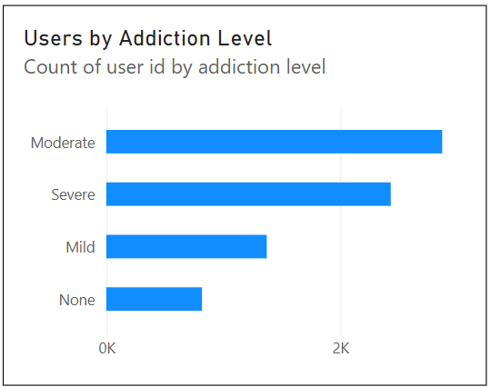

Question 3
What is the proportion of addicted versus non-addicted users across the population?
- Visualization: Donut chart showing Addicted vs Non-Addicted Users (Count of user id by addicted label) with a central 7.5K total volume indicator.
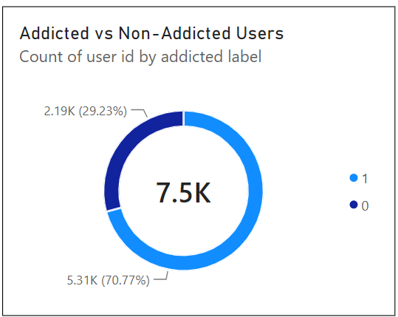
Question 4
Is there a discernible correlation between daily screen time and sleep duration?
- Visualization: Scatter chart showing Daily Screen Time vs Sleep Hours (plotting daily screen time hours along the X-axis and sleep hours on the Y-axis).
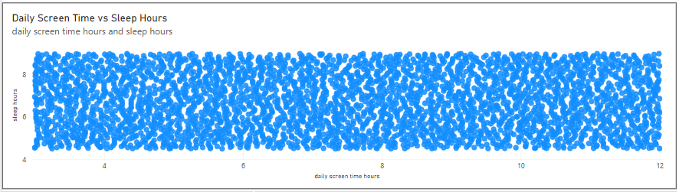

Question 5
How does average daily screen duration vary across different age cohorts?
- Visualization: Column chart showing Average Daily Screen Time by Age Group (30-39, 20-29, Under 20).
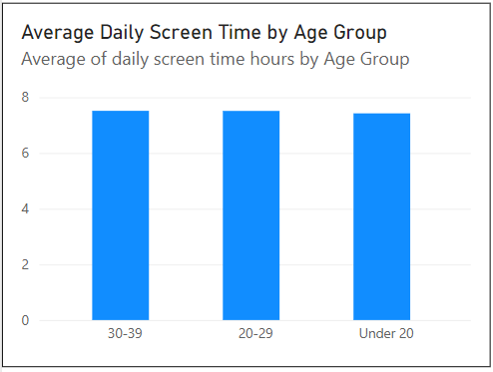
Question 6
How does user engagement in mobile gaming compare against social media usage?
- Visualization: Clustered column chart comparing Average Gaming vs Social Media Usage (Average of gaming hours vs. Average of social media hours).
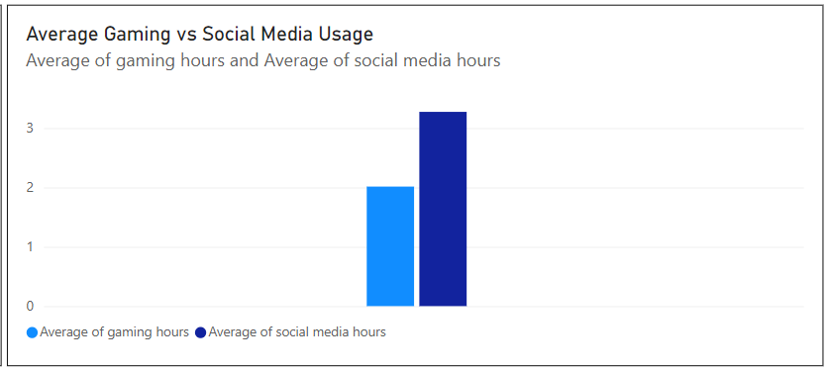

Question 7
How can stakeholders dynamically filter and slice the report data across key user demographics and addiction tiers?
- Visualization: Multi-slicer panel combining Age Group (20-29, 30-39, Under 20), Gender (Female, Male, Other), and Addiction Level (Mild, Moderate, None, Severe).
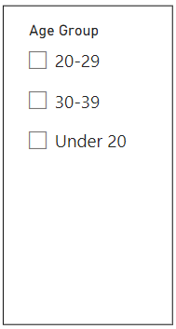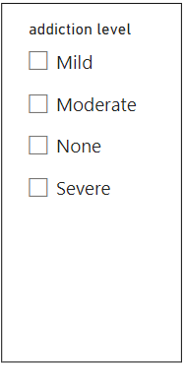
Question 8
What is the total volume of distinct users captured in this study?
- Visualization: Card visual displaying the total Count of user id (7500).

